Практическая работа №17-18
Выполнял: Шеменев ИСП-3-27

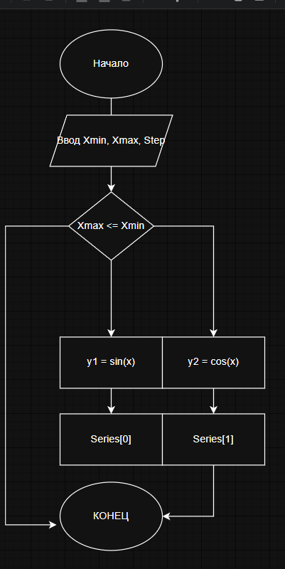
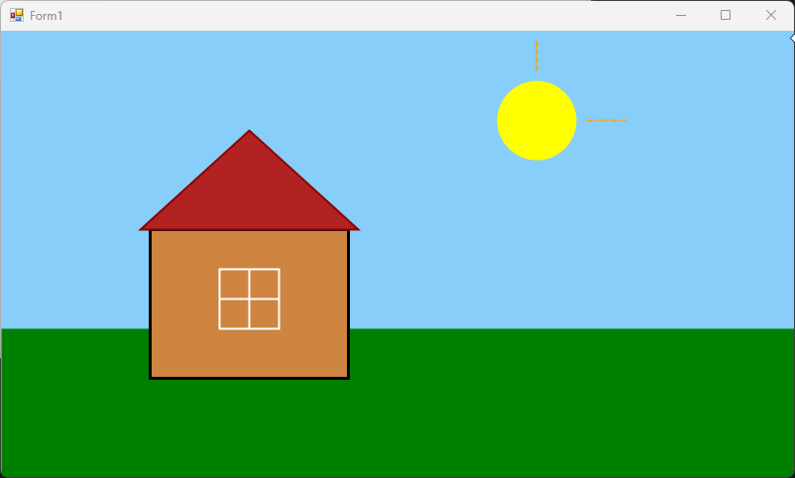
using System;
using System.Collections.Generic;
using System.ComponentModel;
using System.Data;
using System.Drawing;
using System.Drawing.Drawing2D;
using System.Linq;
using System.Text;
using System.Threading.Tasks;
using System.Windows.Forms;

namespace GraphicsLab_17_18
{
public partial class Form1 : Form
{
public Form1()
{
InitializeComponent();
}

private void Form1_Paint(object sender, PaintEventArgs e)
{
Graphics g = e.Graphics;
// Включаем сглаживание, чтобы линии были ровными
g.SmoothingMode = SmoothingMode.AntiAlias;
g.Clear(Color.LightSkyBlue);
SolidBrush grassBrush = new SolidBrush(Color.Green);
g.FillRectangle(grassBrush, 0, 300, this.Width, this.Height);
SolidBrush houseBrush = new SolidBrush(Color.Peru);
g.FillRectangle(houseBrush, 150, 200, 200, 150);
Pen housePen = new Pen(Color.Black, 3);
g.DrawRectangle(housePen, 150, 200, 200, 150);
Point[] roofPoints = {
new Point(140, 200),
new Point(250, 100),
new Point(360, 200)
};
g.FillPolygon(Brushes.Firebrick, roofPoints);
g.DrawPolygon(new Pen(Color.DarkRed, 2), roofPoints);

g.FillEllipse(Brushes.Yellow, 500, 50, 80, 80);
Pen dashPen = new Pen(Color.Orange, 2);
dashPen.DashStyle = DashStyle.Dash;
g.DrawLine(dashPen, 540, 40, 540, 10);

Pen dashDotPen = new Pen(Color.Orange, 2);
dashDotPen.DashStyle = DashStyle.DashDot;
g.DrawLine(dashDotPen, 590, 90, 630, 90);
Pen windowPen = new Pen(Color.White, 2);
g.DrawRectangle(windowPen, 220, 240, 60, 60);
g.DrawLine(windowPen, 250, 240, 250, 300); // Рама
g.DrawLine(windowPen, 220, 270, 280, 270);
}
}
}

